Identifying Suspicious Processes and Malware Analysis Using Sysinternals Process Explorer
EXPERIMENT NO: 09 DATE:
1. AIM
To conduct an in-depth behavioral and structural analysis of active operating system processes using Sysinternals Process Explorer; to evaluate hierarchical parent-child lineages, cryptographic digital signatures, and execution paths; to leverage cloud-based threat intelligence for automated multi-engine malware identification; and to successfully isolate, contain, and terminate unauthorized, masquerading, or anomalous processes to secure system integrity.
2. SOFTWARE / TOOLS REQUIRED
- Operating System: Windows OS
- Forensics Tool: Sysinternals Process Explorer
- Verification Utilities: Web browser for online malware databases (VirusTotal, ProcessLibrary)
3. DESCRIPTION
Sysinternals Process Explorer is an advanced task manager replacement and live system monitoring tool for Windows that provides granular visibility into active processes, system resources, and security handles. It organizes applications into a hierarchical parent-child process tree and utilizes distinct color-coding to denote process states (e.g., pink for suspended, dark blue for system services, green for newly spawned instances). Beyond tracking dynamic resource consumption (CPU, memory, disk) and active TCP/IP connections, Process Explorer supports advanced threat-hunting features such as automated VirusTotal hash verification, digital signature validation, and lower-pane handle/DLL analysis. By inspecting image paths, security tokens, and execution lineage, security analysts can effectively distinguish legitimate system software from masquerading malware, rogue binaries, and unauthorized persistence mechanisms.

4. PROCEDURE
Step 1: Download and Initialization
- Download the official Sysinternals Process Explorer suite from the Microsoft website and extract the archive to a local directory.
- Navigate to the extracted folder, right-click procexp64.exe (for 64-bit systems), and select Run as Administrator to ensure full access to system-level process tokens and attributes.
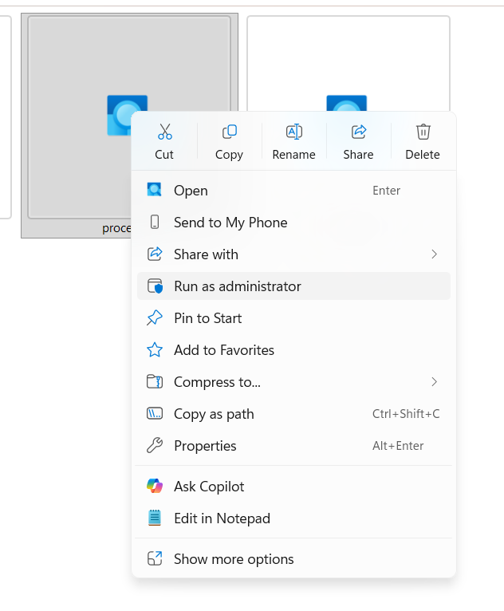
Figure 1: Launching Process Explorer with administrative privileges
Step 2: Interface Familiarization and State Analysis
- Observe the main process tree interface displaying active processes, process IDs (PID), CPU/memory usage, descriptions, and company names.
- Note the color-coding schema: Pink (suspended), Light Blue (user processes), Dark Blue (system services), and Green/Red (newly spawned or exited processes).
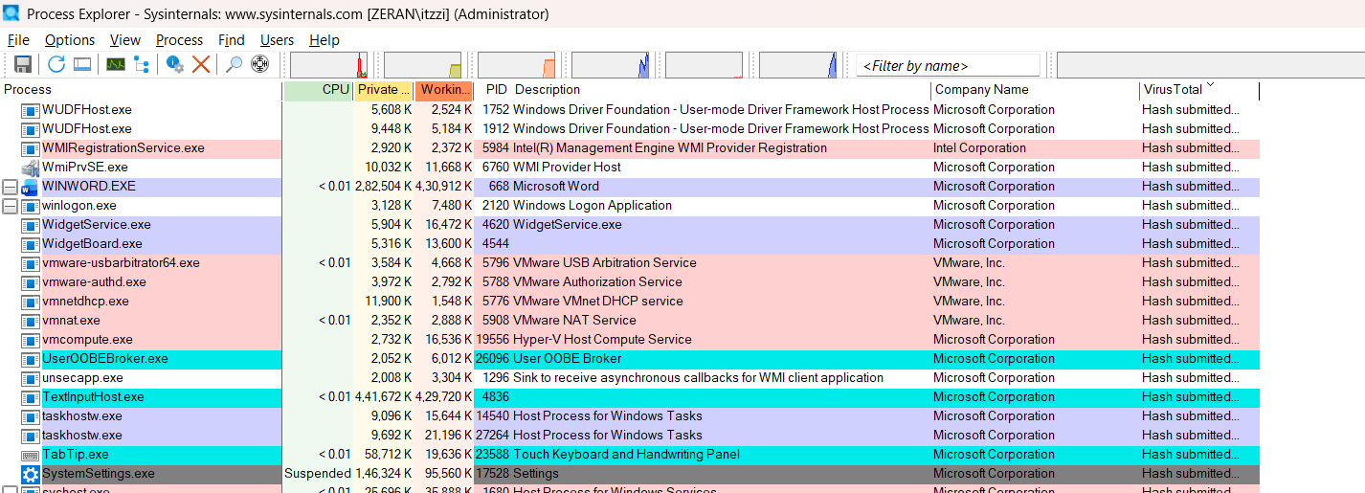
Figure 2: Process Explorer dashboard displaying hierarchical process trees and resource metrics
Step 3: Investigating Suspicious Processes
Perform targeted checks on unfamiliar or high-resource consumption processes:
- Verify Digital Signatures: Right-click the suspect process, select Properties, and check the Image tab for a valid digital signature from a trusted developer.
- Check Execution Path: Inspect the file path under the Image tab; legitimate system binaries must reside in system directories like C:\Windows\System32, whereas malware often runs from user profile temp folders or random directories.
- Inspect Network Activity: Navigate to the TCP/IP tab within the Properties window to identify unexpected or unauthorized external server connections.
- Inspect Loaded DLLs (Lower Pane View): Press Ctrl + D or go to View > Lower Pane View > DLLs. When you click a suspicious process in the upper tree, the lower pane will display all Dynamic Link Libraries loaded into that process. Look for unverified paths, missing company names, or DLL injection attempts where standard system processes load unexpected external libraries.
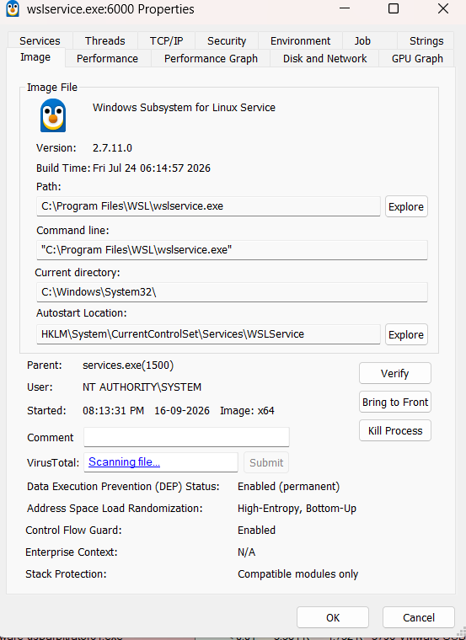
Figure 3: Inspecting image properties, cryptographic signatures, and execution file paths

Step 4: Threat Intelligence Lookup
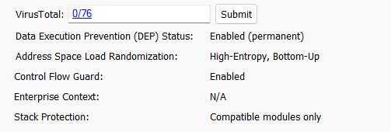
- If a process name or hash appears anomalous (e.g., randomname123.exe), query it against online threat intelligence platforms like VirusTotal or search security databases to verify its reputation.

Figure 4: Querying process hashes against online malware repositories
Step 5: Mitigation and Containment
- If a process is confirmed malicious or unresponsive, right-click it and choose Suspend to halt its activity safely, or select Kill Process to terminate it immediately.
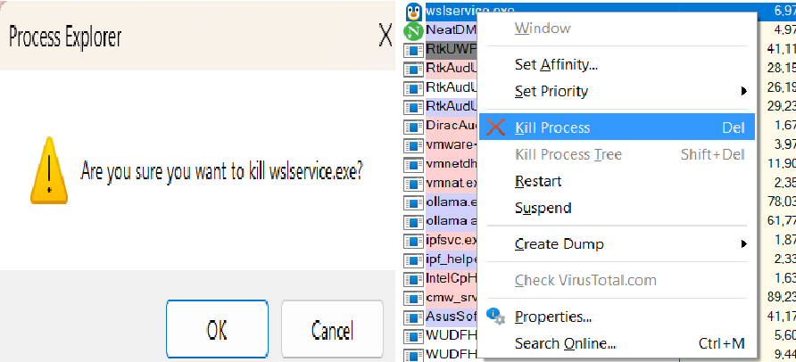
- Locate the source executable using its verified path and remove the file.

Figure 5: Terminating and suspending malicious process handles
Step 6: Comprehensive System Scan
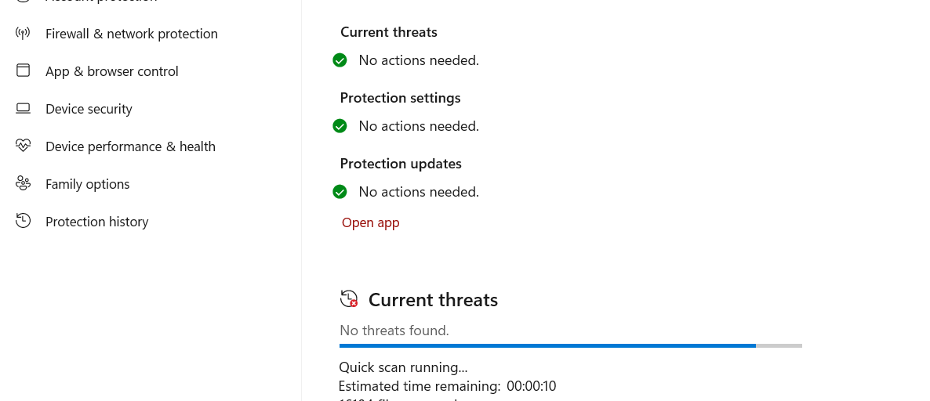
- Following threat mitigation, execute a full system scan using Windows Defender or dedicated anti-malware utilities (e.g., Malwarebytes) to ensure zero residual persistence.
Figure 6: Performing a post-mitigation system scan using Windows Defender

5. OBSERVATIONS
- Process Hierarchy & Lineage Integrity: Legitimate Windows system processes (such as lsass.exe and winlogon.exe) correctly traced back to trusted system paths (C:\Windows\System32) and exhibited valid digital signatures from Microsoft Corporation. Parent-child relationships followed standard OS architecture (e.g., services.exe spawning child services).
- Automated Threat Intelligence Integration: Enabling VirusTotal integration allowed instant multi-engine cryptographic hash verification. Clean binaries yielded a 0/72 detection ratio, whereas anomalous binaries immediately flagged high detection ratios across multiple security vendors.
- Network & Resource Correlation: Anomalous processes flagged during investigation exhibited unauthorized outbound TCP/IP socket connections to external.
RUBRICS
Criteria & Marks Assigned | Mark Allotted | Mark Awarded
1. GitHub Activity & Submission Regularity | 3
2. Application of Forensic Tools & Practical Execution | 3
3. Documentation & Reporting | 2
4. Engagement, Problem-Solving & Team Collaboration | 2
Total | 10

6. RESULT
Sysinternals Process Explorer was successfully utilized to monitor active system processes, verify digital signatures and execution paths, and analyze process trees. Malicious or unauthorized processes were effectively identified, isolated, and terminated, ensuring system integrity and security.

